Name : Saurabh Jadhav

Topic : Route53 service

Assignment no. : 25

1. Create 2 instances in virginia region and add them in elastic load balancer.
2. Created 2 instances.

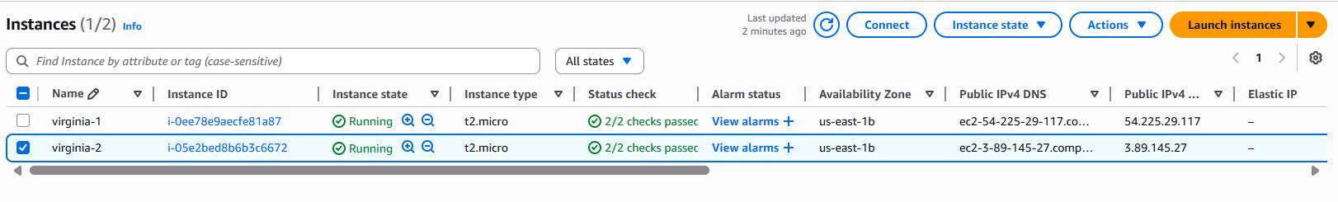

Added script to create html web page.

#! /bin/bash

Yum install httpd -y

Systemctl start httpd

Systemctl enable httpd

Systemctl status httpd

Echo “give instance names” > /var/www/index.html

1. Create target group for load balancer.

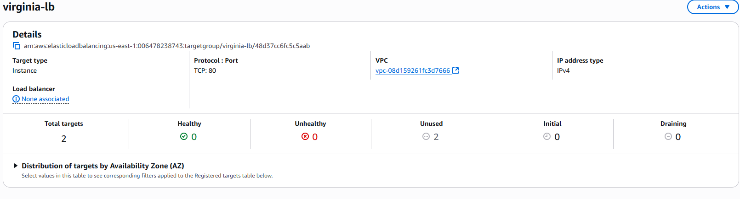

1. Create load balancer.

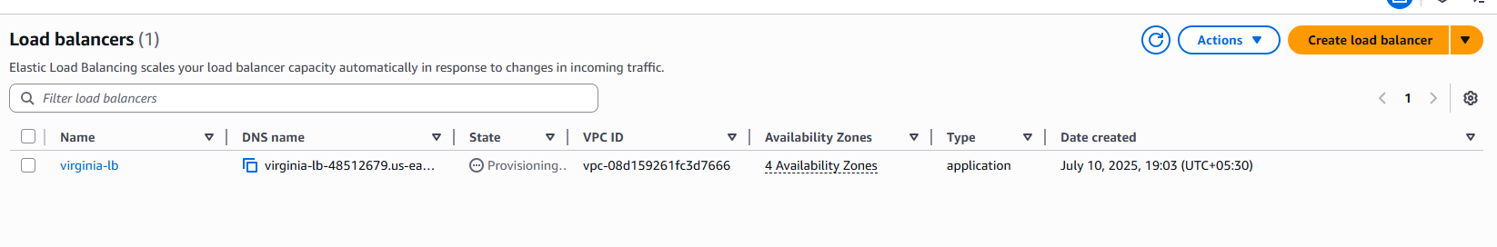

1. Similarly Create 2 instances and load balancer in Mumbai region.

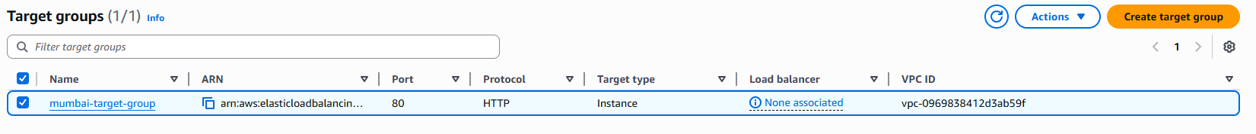

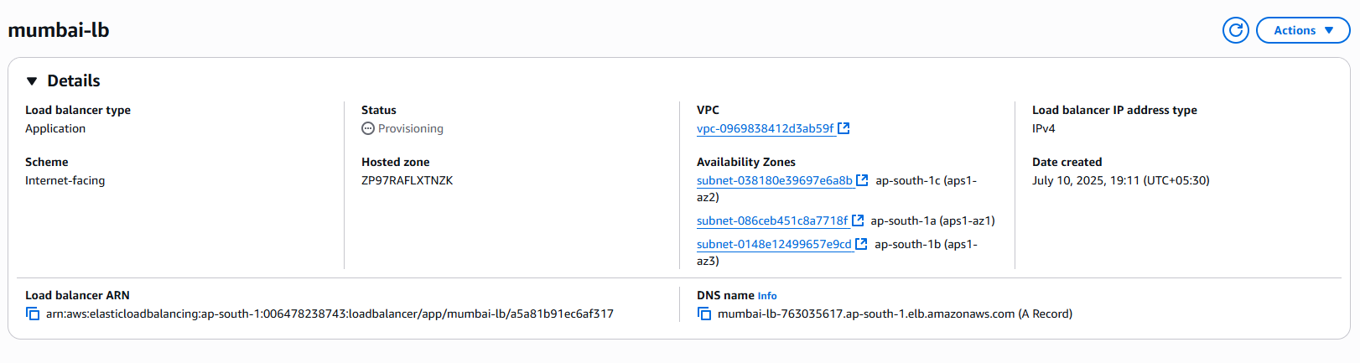

1. In domain register, we can search for domain we require. Then it will display exact match and other suggestions for it with pricing.

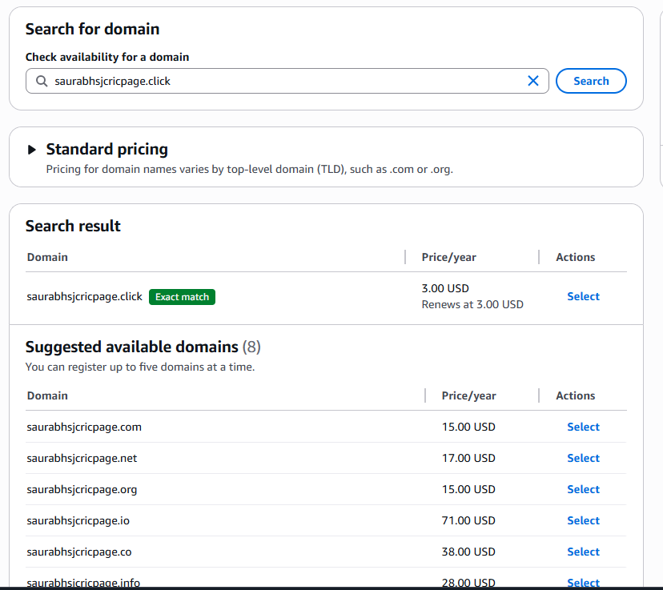

1. Create hostzone.

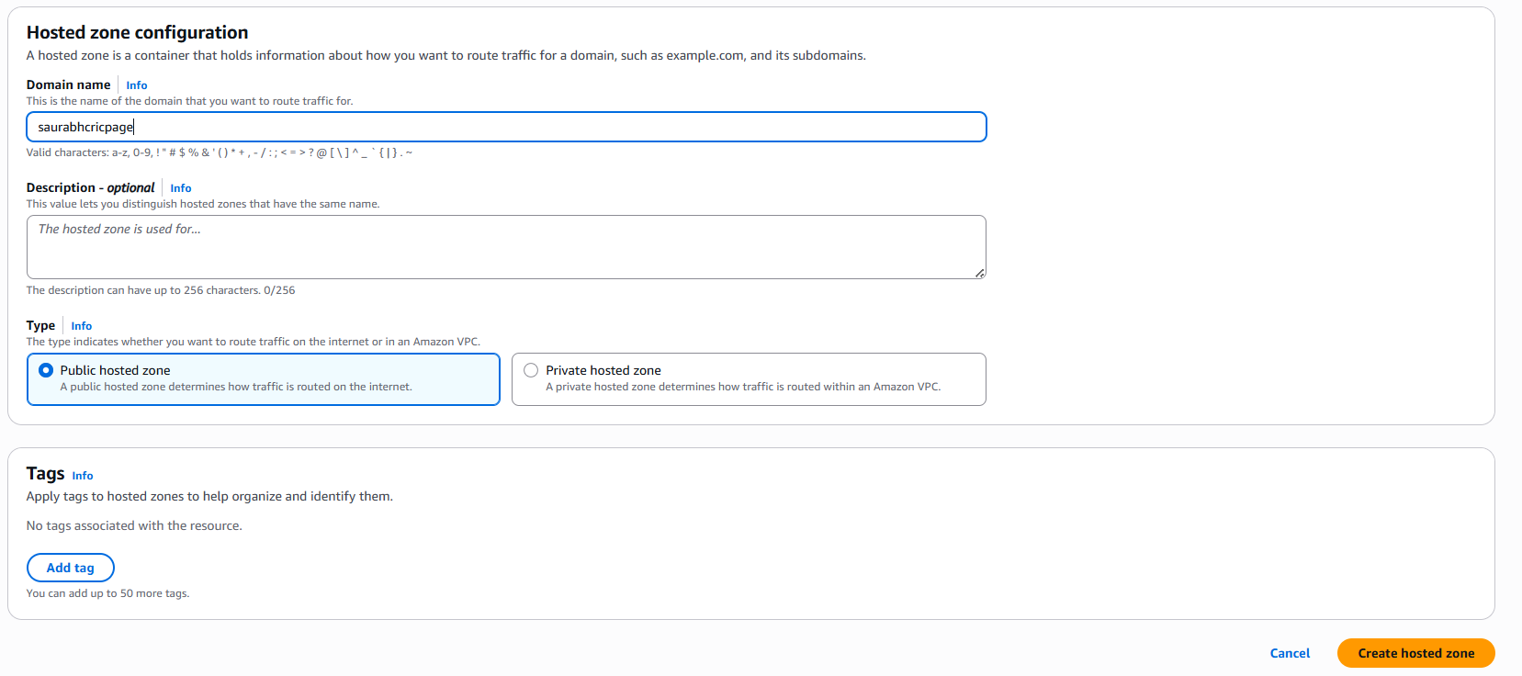

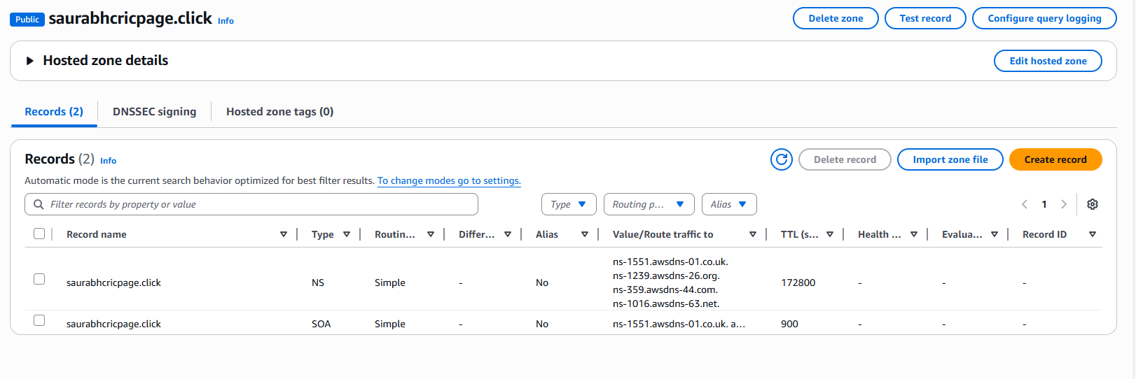

1. Create new records in host zone.
2. Routing policy – Simple routing.

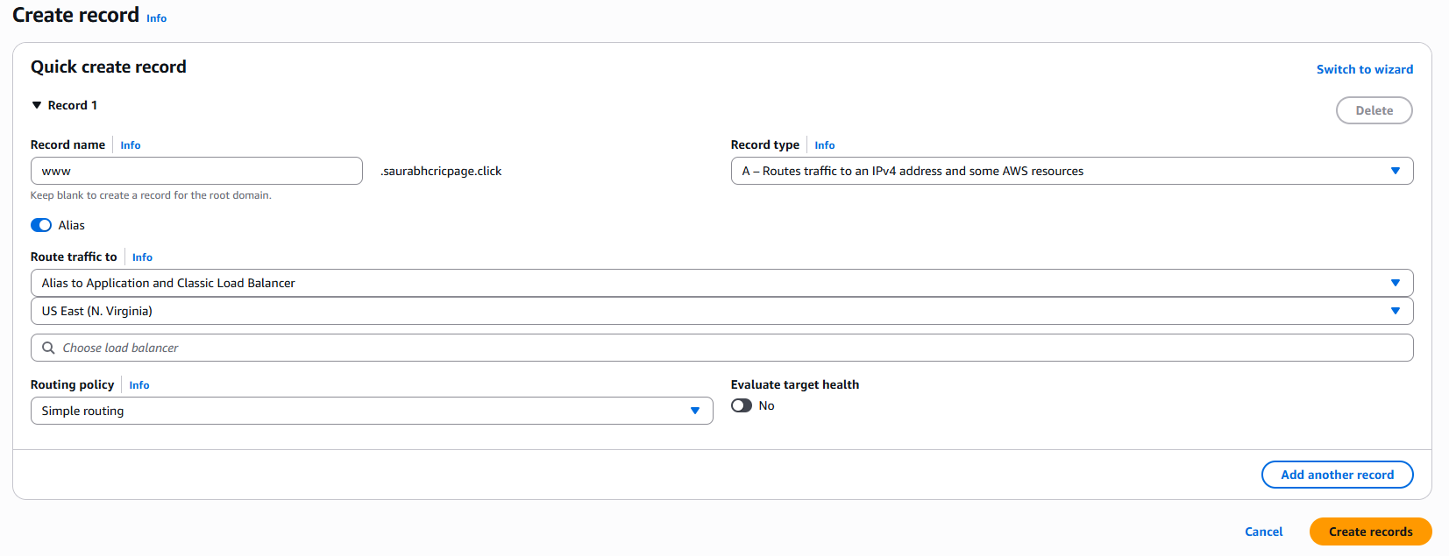

Record gets added.

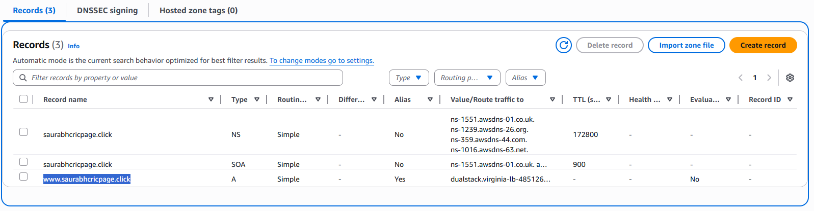

1. Routing policy – Weighted.

We can provide weight between 0-255.

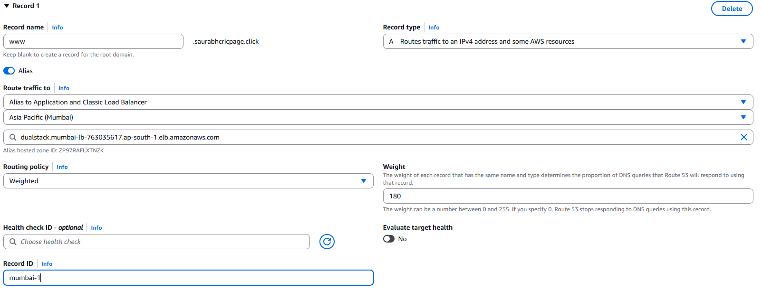

Create another record with weighted routing policy.

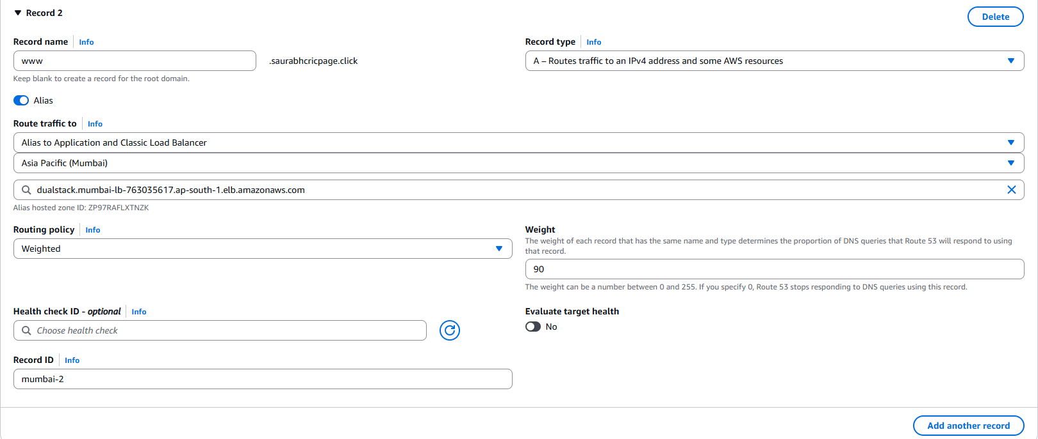

1. Routing policy – latency

We have to provide another region for latency if Mumbai region goes down.

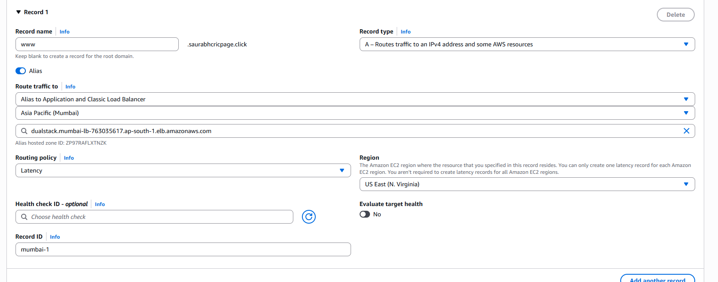

1. Routing policy – Failover

Here we have to select record as primary or secondary.

Primary record will be accessed by default and secondary record will be accessed when primary record is unavailable. Also enable “evaluate target health”.

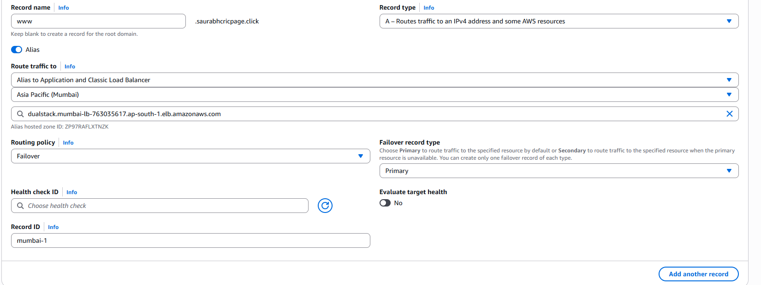

1. Routing policy – Geolocation.

In this we need to provide the location from were we will receive the requests.

